Date: 17.10.2025
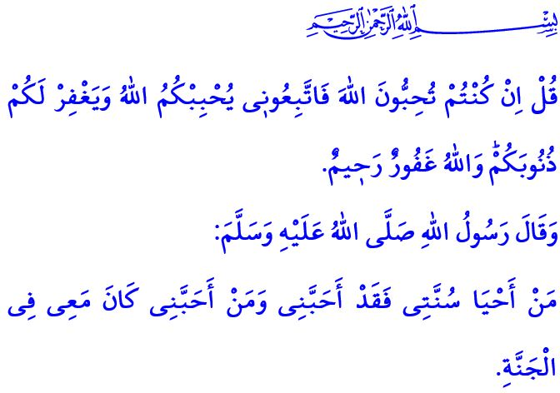SUNNAH AL-SANIYYAH: A MUSLIM’S GUIDE TO LIFE
Honorable Muslims!
The Holy Qur’an, our guide for life, is the divine message that tells us about our Lord and teaches us the wisdom of creation and the purpose of life. It is a guide that distinguishes between truth and falsehood, right and wrong. It is a cure for hearts, a mercy for souls, and a source of tranquility for the spirit. The Sunnah al-Saniyyah, on the other hand, is the Qur’an manifested in life, faith translated into practice, and Islam embodied in action. In the verse I have recited at the beginning of the khutbah, our Lord Almighty states, “Say, ˹O Prophet,˺ ‘If you ˹sincerely˺ love Allah, then follow me; Allah will love you and forgive your sins. For Allah is All-Forgiving, Most Merciful.’”
Dear Believers!
In one of his hadiths, our Prophet (saw) says, “Whoever revives my Sunnah has loved me, and whoever loves me will be with me in Paradise.” To live in accordance with the Sunnah is to love Allah the Almighty more than anyone or anything else, to obey His commands, and to refrain from His prohibitions. It is to engrave the Holy Qur’an upon our hearts and lives and to embody the morals of Islam. To live by the Sunnah is to ensure that love and affection prevails within the family. It is to observe what is halal and haram in trade and to remain steadfast in truthfulness and integrity. To live according to the Sunnah is to make life bearable for one another and to cause no harm to anyone, whether by hand or by tongue. To live by the Sunnah is to act with a sense of being an ummah, to love one another for the sake of Allah, to unite like the bricks of a building, and to share both our joys and sorrows. To live according to the Sunnah is to spend a lifetime without letting one day resemble another.
Esteemed Muslims!
As in the past, humanity today remains in need of the timeless messages of the Messenger of Allah (saw). His Sunnah contains virtues that touch every heart, speak to every individual, and guide every community. This is expressed in the Holy Qur’an as follows, “Indeed, in the Messenger of Allah you have an excellent example for whoever has hope in Allah and the Last Day, and remembers Allah often.”
Dear Believers!
Our duty is to regard the commands of Allah and the Sunnah of the Messenger of Allah (saw) as more important and valuable than anything else. It is to strive to embody the noble character of our Prophet (saw) in every aspect of our lives. It is to take greater care in instilling the love of our Prophet (saw), intricately, into the hearts of our children and youth. Let us not forget that it is impossible to truly understand the Holy Qur’an, strive to live by Islam, or attain Allah’s pleasure and love without giving due regard to the Sunnah of the Messenger of Allah (saw).

I would like to conclude this Friday’s khutbah with the following admonitions of our Prophet (saw) from his Farewell Khutbah: “I leave behind two things for you, and you will never go astray as long as you hold fast to them: the Book of Allah and the Sunnah of His Prophet.”

Ali ‘Imran 3/31.
Tirmidhi, ‘Ilm, 16.
Ahzab, 33/21.
Muslim, Hajj, 147; Muwatta’, Qadar, 3. General Directorate of Religious Services

